Page Hierarchy:
- Home
- About
- My degree
  - COM1001 – Software engineering
  - COM1002 – Foundations of compsci
  - COM1003 – Java programming
  - COM1005 – Machines and intelligence
  - COM1006 – Devices and networks
  - COM1008 – Web and internet technology
    - Javascript
- News
- The Diamond
- Contact
- Accessibility

Accessibility:
- A Suitable alt text attribute should be chosen for images, and should only be supplied where an image conveys information.
- The page title should be descriptive and informative of the page content for screen readers, text only browsers etc.
- Link text should have clear meaning, e.g. not “click here”, for screen readers, text only browser, cognitively impaired users etc.
- Sensible text/element order without css: for screen readers, text only browsers, slow connections, users who have disabled css for whatever reason (or are using custom css) etc.
- Colour palette should be suitable for colour-blind users. i.e. no colours near each other which differ only in hue, or mainly in hue.
- Resizing browser default text size should adjust the page text size to accommodate visually impaired users
- Should not depend on a specific font in case users want to use their own e.g. dyslexic users using dyslexia friendly fonts (probably an option to enable a dyslexia friendly font should also be provided)
- Sensible tab order for non-mouse users
- Everything should be accessible with just mouse, or just keyboard (or on-screen keyboard for mouse only users/mobile users)
- No changing elements/no fast changing elements (e.g. no fast image carousels) to allow slower users time to read/view
- No flashing content: Don't want to trigger epileptic seizures etc.
- Captioning for any audio/video media for users who are hard of hearing

Mockups:
In this mockup the palette has been selected based only on one hue, but varying the saturation and lightness, which means that none of the contrast comes from changing the colour, this means that for most colour-blind people the various colours in this palette are still as distinguishable from each other as for normally sighted people.
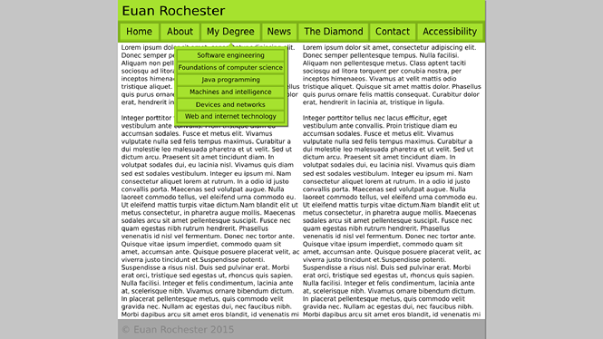Illustration 1: PC Mockup

When this layout is in use pressing or hovering over the “My Degree” navigation button will trigger a dropdown showing links to all of the modules pages. This is to keep the size of the header minimal and unobtrusive, as well as making the navigation uncluttered and hierarchically structured.

The page is split into two columns for extra readability, also if an aside to the main article is needed then the left column can be enlarged and within the shrunk right column the aside can be placed.

The footer of the page is intentionally in a muted palette so as to not distract from the main content. The colour palette of the footer also is based on only one hue thereby reducing the likelihood that a colour-blind person would be unable to distinguish between the colors.
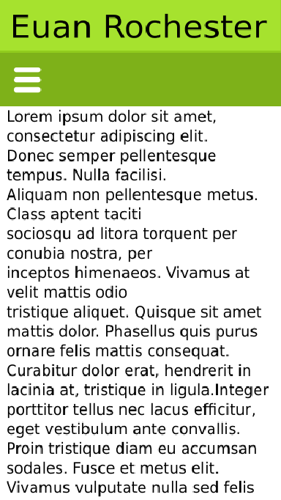Illustration 2: Mobile Mockup
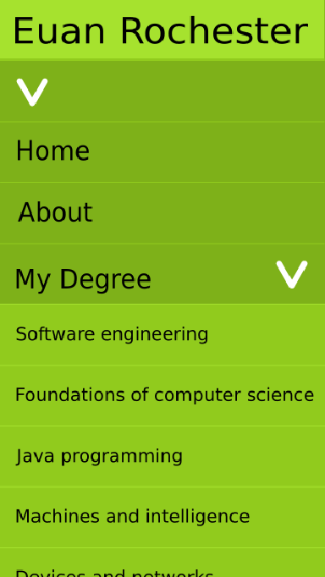Illustration 3: Mobile menu Mockup
The mobile layout is designed to increase screen space during browsing by totally hiding the menu in an accordion type collapsing menu (similar to the “multi toggle” example at responsivenavigation.net).
Menus which were previously dropdowns are now nested accordions, and as you get deeper into the nest the colour changes to indicated that this is a sub menu. Icons are also used to indicate to the user before they open the submenu that it is a submenu and not just another link.

For screen readers it is important to make sure that all of the menus and sub menus are “visible” all at once as changing content for screen reader users is often confusing, and screen reader users may have no obvious way to open the sub-menus (or even realise that they are sub-menus) otherwise.

A third layout with the “multi toggle” style menu, but with small gutters on each side of the content and still using 2 columns could be used on mid-sized screens (i.e tablets) if it is more readable than either of the two other 2 layouts. This would have the benefit of reducing the header clutter, insuring the navigation elements are not cramped, while also maintaining the potentially more readable two column layout.

Ideally the site will pass googles mobile-site tester as this ensures that (according to google):
- Text can be read without zooming on mobile
- Mobile users do not have to scroll horizontally, or zoom to see all page content
- Links are far enough apart that it is easy to press the intended one first time
All of which greatly contribute to the ease of use of the site on mobile.

The site should make use of semantic html5 elements where suitable e.g. 'nav' for navigation, 'main' for primary content, 'aside' for less relevant (or secondary) content, 'article' for textual content which still makes sense by itself. The use of semantic elements is especially important as modern screen readers are now using (or beginning to use) these semantic elements to assist in easier navigation, and identification of important parts of the page.

